Ecological Modelling, 36 (1987) 181-194
Elsevier Science Publishers B.V., Amsterdam -

YIELD PREDICTION MODELS FOR PINUS MERKUSII
PLANTATIONS IN INDONESIA
GUILLERMO A. MENDOZA
Department of Forestry, University of Illinois at Urbana-Champaign, Urbana, IL 61801 (U.S.A.)
and JANES SIAHAYA
Faculty of Forestry, Mulawarman University, Samarinda (Indonesia)
(Accepted 23 April 1986)
ABSTRACT
Mendoza, G.A. and Siahaya, J., 1987. Yield prediction models for Pinus merkusii plantations
in Indonesia. Ecol. Modelling, 36: 181-194.
Two yield prediction models for Pinis merkusii plantations are developed and described in
this paper. The first model is formulated as a system of two simultaneous equations involving
basal area and yield as two endogenous variables. The system of equations is considered
just-identified. Hence, two-stage least squares were used as an estimation procedure. The
second model is a single-yield equation whose parameters are estimated by ordinary least
squares.
INTRODUCTION
Printed in The Netherlands
Pinus merkusii Jungh et de Vries is indigenous to Northern Sumatra,
Indonesia. In the early 1920s, it was tried in plantations in the islands of
Sumatra and Java. Since 1931, it has been planted extensively not only in
these islands, but also in Bah and Sulawesi (Ferguson, 1954)

.

Three previous studies have examined the growth and development of P.
merkusif in Indonesia The firs! is the pioneering work of Ferguson (1954)
He used smooth-fitted curves to describe the height of each age class given
an average site quality. Other growth curves for other site qualities were
developed based on some adjustments from the average site quality.
Sumarna and Sudiono (1972) developed a local volume table for P.
merkusii plantations at North Bandung (West Java). Later, Suharlan et al.
(1976) improved these tables by adding more sample trees. Siahaya (1973)
also developed a tree volume table for the same species in West Java, using
stem and crown diameters.
Data and study area
The data used in this study were obtained from three plantations located
in West, Central and East Java. All these plantations are owned and
managed by the government though PERHUTANI, a Forest State Corpora-
tion. At West Java, the data were collected from 4- to 34-year-old stands
which were planted from 1948 to 1978. At East Java, the data were collected
from 11- to 27-year-old stands which were planted from 1955 to 1971.
Finally, at Central Java, the stands are 4-19 years of age, and were planted
from 1963 to 1978.
From these three sites, 114 permanent sample plots, whose sizes vary
from 0.12 to 0.6 ha, were selected. These sample plots were measured and
remeasured by the Forest Research Institute (FORI, Bogor) every 2 years
since the plantations were about 4 years old. The plots are of various ages.
Hence, depending on the age of the plots, two to eight remeasurements were
done, so that there were 545 observations taken from these 114 sample plots.
TABLE 1
Original stand
SDacine
No. of sample
nlots/No. of
Distribution of sample plots and number of observations by original stand spacing

TABLE 2
Total
Distribution of 545 observations on 114 permanent sample plots by stand age and original
stand spacing
Original stand Stand age interval (years)  spacing  (mXm) | 0-5 | 6-10 | 11-15 | 16-20 | 21-25 | 26-30 | 31-35
lèxli |  | 2 | 4 | 4 | 2 |  |  | 12
2 Xl| |  | 1 | 5 | 4 | 2 |  |  | 12
2 X2 |  | 1 | 2 | 2 | 1 |  |  | 6
3 Xli |  | 6 | 12 | 12 | 6 |  |  | 36
3 X2 | 8 | 65 | 103 | 111 | 42 | 2 |  | 331
2\ Xl\ |  |  | 1 | 3 | 1 | 1 | 2 | 8
3 X 3 | 8 | 40 | 30 | 16 | 6 |  |  | 100
4 X 3 | 4 | 7 | 10 | 11 | 8 |  |  | 40
Total | 20 | 122 | 167 | 163 | 68 | 3 | 2 | 545
TABLE 3

Distribution of 545 observations on 114 permanent sample plots by stand age and average
total height of dominant trees of the plots
Stand age | Average total height interval (m)
interval | 5.0-10.2 | 10.3-15.5 | 15.6-20.8 | 20.9-26.1 | 26.2-31.4 | 31.5-36.7
(years)
0- 5 | 20
6-10 | 24 | 85 | 13
11-15 |  | 8 | 108 | 51
16-20 |  |  | 8 | 118 | 35 | 2
21-25 |  |  |  | 6 | 54 | 8
26-30 |  |  |  |  | 2 | 1
31-35 |  |  |  |  |  | 2
Total | 44 | 93 | 129 | 175 | 91 | 13

TABLE 4

These plots were chosen so that stand age, average total height of
dominan! trees, and si te Qua lity are well distribm H ^nd represented. Tables
1 to 4 summarize the distribution oí the samj^ and the number of
observations.
FACTORS AFFECTING YIELD
Clutter et al. (1983) provide a comprehensive review of the development
of various types of growth and yield models for different types of forests;
the regression models developed in this paper are adaptations of the
Shumacher-type yield model described. As pointed out earlier, the primary
purpose of the model is to generate expected-yield tables which can be used
for growth and yield analysis. Emphasis is given to the effect of thinning on
the growth and yield of P. merkusii plantations. For this purpose, the
regression model includes other factors such as thinning intensity which is
based on a thinning guide prescribed by the Forest State Corporation
PERHUTANI (1982).
There are several factors that affect the yield of an even-age plantation
forst. These include: (1) management regime; (2) genetic variation; (3) stand
age; (4) site quality; (5) original spacing; and (6) stand density. In this
paper, the genetic variation and management regime (except intermediate
cutting or thinning) were held constant and hence they were not considered
as primary factors in the model development.
Management regime. In formulating the yield prediction model for P.
merkusii plantations, the management regime was considered constant be-
cause all plantations were managed using the same management guides
under the control of FORI and PERHUTANI. However, thinning was
considered as a primary factor or variable because the stands were subjected
to different levels or intensities of thinning. The thinning intensity was based
on the number of trees and average total height of the dominant trees in the
stand
the seeds used for planting came from mother trees of the same variety of P.
merkusii Jungh et de Vries, and from the same island (i.e., Java). Hence,
based on the origin of seeds, it was assumed that the genetic variation
among the plantations was not significant.
Site quality. Stand height at a given stand age was used as the index for site
quality. Since no site index equation was available for P. merkusii planta-
tions in Java, it was necessary to develop one for the study. Based on 545
observations taken from 114 permanent sample plots, a guide equation was
used to develop the site index equation.
Original spacing. Results of previous studies in pine plantations (Ware and
Staheline, 1948; Bamble et al., 1949; Bennett, 1963; and Pimmanrojnagool,
1979) have used original spacing as primary factor in yield prediction. For
the present study, eight types of original spacing were used. Each spacing
was expressed as the product of its length and width.
Stand density. For this study, stand density was measured or expressed in
terms of basal area per ha.
MODEL FORMULATION AND DEVELOPMENT
Two alternative formulations and estimation procedures were examined
in this study. The first formulation involves the use of a single-yield
equation whose parameters were estimated by ordinary least squares (OLS).
The second formulation adopts the simultaneous-equations approach. In the
latter formulation, the model parameters were estimated by two-stage least
squares (2 SLS).
The two alternative formulations were examined because previous studies
on two other pine species in Southeast Asia, namely Pinus kesiya in
Thailand (Pimmanrojnagool, 1979) and Benguet pine in the Philippines
(Revilla, 1976) have reported satisfactory results using the two formulations.

were specified so that: (1) yield equation is expressed as a function of stand
pge. File o$^-rrv< stand spacing., thinning intensity and stand basal
area, and other equations were specified in addition to the yield equa-
tion.
Single-equation method. Several forms of the single-equation yield predict-
ion model were considered and examined in the study. After careful ex-
amination of these various single equation forms, the model described in
equation (1) was chosen because it exhibited some desirable statistical
properties (e.g. high multiple correlation, R², and highly significant regres-
sion coefficients), and primarily because it allows direct comparison with the
yield equation of the simultaneous equations model. Hence, the single-yield
equation is formulated and specified as:
log Y = + ^n(1/A) + b₁₂(S) + b₁₃(sp) + b₁₄(ti) + b₁₅(log ba) (1)
where Y is stand volume or yield (m³/ha); A age of stand (years); S site
index (m), at base age of 20 years; sp original stand spacing (m²); ti
thinning intensity (%); and ba basal area (m²/ha); b₁₀, b_{u}, b₁₂, b₁₃, Z?₁₄, b_{l5}
are model parameters.
Simultaneous-equation method. The theory of simultaneous-equations in
regression analysis and econometrics is described in many books (e.g.,
Furnival and Wilson, 1970; Kmenta, 1971; Johnston, 1972; Chiswick and
Chiswick, 1975) and will not be discussed in detail in this paper. However,
some concepts will be briefly presented to highlight the development of the
yield prediction model.
In formulating the simultaneous equations, basal area and yield are the
two endogenous variables. The structural form of the two equations are
specified as follows:
log ba = b₂₀ + b_{2l}(l/A) + b₂₂(S) + b₂₃{S/A) + ¿>₂₄(sp) + Mti) (2)
log Y=b₃₀ + b₃₁ (1/A) + b₃₂(S) + b₃₃(sp) + b₃₄(ti) + b₃₅(log ba) (3)
intensity is not included as a distinct explanatory variable, whereas the
formulation in equation (3) allows the specification of thinning intensity
directly. With the formulations specified in (3), predicted yield tables based
on the thinning guides prescribed by PERHUTANI can be generated.
From the above equations, stand age, site index, original stand spacing
and thinning intensity are the exogenous variables which are determined
outside the model. The system of two simultaneous equations consisting of
equations (2) and (3) is considered just-identified. Note that the reduced
forms of the system can be described as follows:
log (ba) = a20 + a₂₁(l/A) + a₂₂(S) + a₂₃(S/A) + a₂₄(sp) 4- a₂₅(ti) (4)
log Y= a₃₀ + a₃₁(l/A) + a₃₂(S) + a₃₃(S/A) + ¿z₃₄(sp) + ¿7₃₅(ti) (5)
where
ª20 ^{= b}20
ª21 ^{= b}21
ª22 ^{= b}22
ª23 ^{= b}23
a₂₄ = b₂₄
ª25 ^{= b}25
From the reduced form of the two simultaneous equations, it can be
observed that the structural parameters (i.e., b₂₀, b₂₁₉ ...,b₂₆\ b_{3Q}, b₃₁,
. . . ,b₃₅) can be solved from the reduced form parameters (i.e.,
a20, a_{2l},..., a₂₅; a₃₀, a₃₁, ...,a₃₅) using the relationships in equation (6).
Furthermore, it can be observed from the relationships in (6), that a unique
solution for the structural parameters exist given the values of the reduced-
form parameters ª. This condition suggests that the structural equations are
just-identified.
30 | = ^{b}30 | + b₃₅b₂₀
31 | = b₃₁ | + b₃₅b₂₁
32 | = b₃₂ | + b₃₅b₂₂
33 | = b₃₅ | + b₂₃
34 | = b₃₃ | + ^{b}35^{b}2A
35 | = b₃₄ | + b₃₅b₂₅

(6)
Econometric theory has shown that if the system of simultaneous equa-
tions is considered just-identified, the best estimation procedures are indi-

OLS, except that (log ba) is not in raw form as in equation (1), but in its
estimated value obtained from the first step. Hence, the model specification
for the simultaneous equation model estimated hy 2 SLS is as follows:
— First stage:
log ba — b₂₀ + b₂₁(l/A) + b₂₂ b₂₃(S/A) + b₂₄ (sp) + ¿>25 (ti)
Second stage:
log Y =
b₄₀ + b_{4l}(l/A) 4- b₄₂(S) + ¿>43(sp) + ¿>44(ti) + b₄₅(log ba)
where log ba = is the predicted value of log ba obtained from the first
stage.
RESULTS AND DISCUSSION
Site index
(7)
Techniques for modeling site index are reviewed comprehensively in
Clutter (1983). For this study, the guide curve method was adopted in
modeling site index. Following this method two forms of the height guide
curve and site index equations were formulated and estimated as follows:
— Height guide equations:
log H = 0.323187 + 0.855941(log A)
R² = 0.94
(8)
log H = 0.2459 + 0.86426(log A)
+ 0.02394(log E) 4- 0.000445(sl)
R² = 0.94
Site index equations:
(9)
log S = log H + 0.855941(log bage - log A)
= 1.1136 + log H + 0.8559 log A

Site index equations (9) and (10) are guided by (7) and (8), respectively.
Equation (7) is based on the model commonly used for height guide curves.
However, as described by (7), log A was used instead of the reciprocal of
age as originally suggested by Shumacher (1939) because the 545 observa-
tions fitted the alternative model better, as shown by the high value of the
multiple correlation coefficient, R². Between equations (9) and (10), (9) was
chosen as the site index equation for the study because the goodness of fit
for both height guide curves are almost the same as reflected by their R²
which are almost equal.
Simultaneous-equations yield model
Solving the parameters of the simultaneous-equations model formulated
by equations (2) and (3) by 2 SLS, the following equations were derived:
log ba = 2.0400 - 1.6610(1/^4) - 0.0064(5) + 0.0558(5/4)
+ 0.0074(sp) - 0.0201(h) (11)
R² = 0.84119; i?² (adjusted) = 0.83972
log Y= 1.7310 - 4.1822(1/^4) + 0.0059(5) + 0.00519(sp)
- 0.00678(ti) + 0.556684(log ba) (12)
R² = 0.93322; ,R² (adjusted) = 0.93260
Single-equation yield model
Applying OLS directly to equation (1), the following model was derived:
log Y= 1.9244 - 4.1989(1/4) + 0.0057(5) + 0.0059(sp)
- 0.0088(ti) + 0.4558(log ba) (13)
R² = 0.94271; .Readjusted) = 0.94218.
Comparison of estimation vrocedures and results

TABLE 5  Regression coefficients estimated by OLS and 2 SLS at various sample sizes  Method | Number of | Regression coefficients
 | observations | ¿>10 | ¿>11 | ¿>12 | ¿>13 | ¿>14 | ¿>15
OLS | 300 | 2.0751 | 4.2506 | 0.0065 | 0.0077 | 0.0105 | 0.3615
 | 400 | 2.0348 | 4.2210 | 0.0068 | 0.0061 | 0.0103 | 0.3840
 | 500 | 2.0012 | 4.2533 | 0.0064 | 0.0055 | 0.0097 | 0.4092
 | 545 | 1.9244 | 4.1990 | 0.0058 | 0.0060 | 0.0088 | 0.4559
 | Variance of
 | estimates | 0.00306 | 0.000501 | 0.00000013 | 0.00000068 | 0.00000044 | 0.00122
 |  | ¿>30 | ¿>31 | ¿>32 | ¿>33 | ¿>34 | ¿>35
2 SLS | 300 | 1.7767 | 4.2242 | 0.0067 | 0.0066 | 0=0074 | 0.5172
 | 400 | 1.8428 | 4.1447 | 0.0059 | 0.0065 | 0.0065 | 0.4896
 | 500 | 1.8607 | 4.1621 | 0.0062 | 0.0057 | 0.0082 | 0.4798
 | 545 | 1.7310 | 4.1822 | 0.0059 | 0.0052 | 0.0068 | 0.5567
 | Variance of
 | estimates | 0.00269 | 0.00087 | 0.00000011 | 0.00000033 | 0.00000042 | 0.00088

Johnston (1972) has suggested that a sufficient condition for a consistent
estimator is that the bias and the variance should approach zero as the
sample size increases. To empirically verify whether the two estimation
procedures exhibit this property, the regression coefficients were estimated
at four different sample sizes. These samples used were randomly chosen
from the set of 545 observations. Only sample sizes which are considered
large enough (i.e., from 300 to 545) were considered for the analysis. The
results are summarized in Table 5.
It can be observed from Table 5 that the simple variance of the regression
coefficients estimated by 2 SLS is consistently smaller, except for b_{u} and
b₃₁. This indicates that the estimated regression coefficients using 2 SLS
exhibit less divergence compared to OLS when the sample size is large

In validating the model, two significant aspects were considered: (1)
statistical validation, and (2) biological validation. Statistical validation
involves the testing of the significance of the regression coefficients and the
multiple correlation coefficient. In addition, a simple chi-square test was
performed to test how close the predicted yield values are compared to the
actual volume measured from 102 observations.
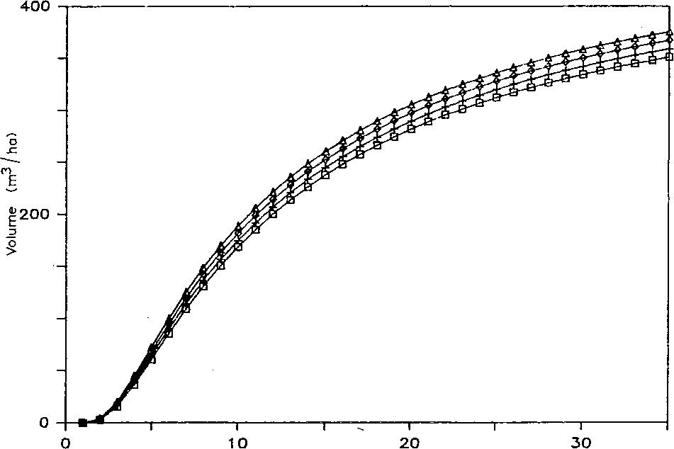
Age (Years)
□ Sl=21 + Sl=24 o §1=27 A Sl=30

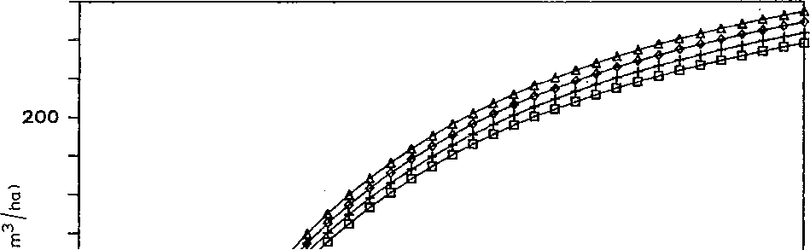
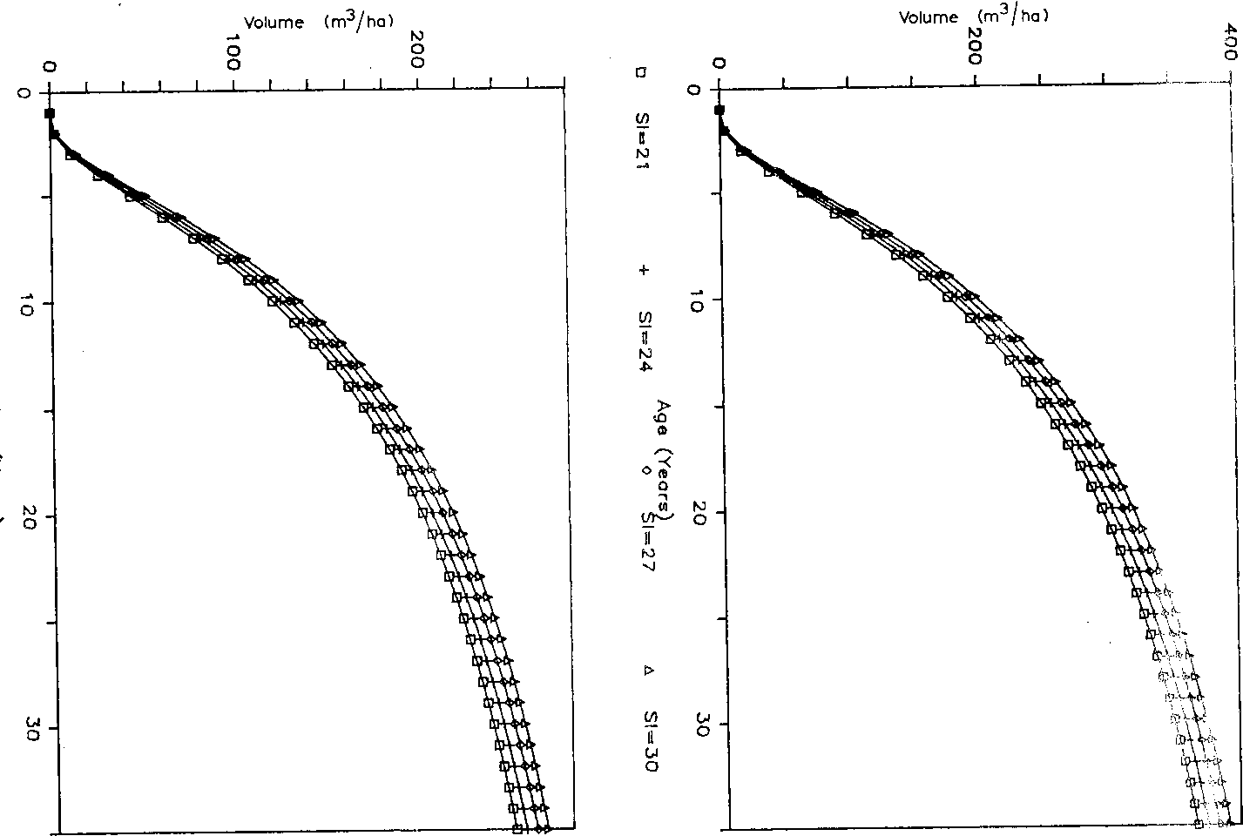
Yield tables and curves. As pointed out earlier, the primary purpose of
developing the growth and yield prediction models is to generate predicted
yield tables for P. merkusii plantations based in: (1) original spacing, (2) site
quality, and (3) thinning intensity as prescribed by PERHUTANI. To
demonstrate the use of the models for growth and yield analysis, yield tables
and curves are generated using equations (11) and (12) as shown in Figs. 1
and 2.
SUMMARY AND CONCLUSIONS
This study was conducted to develop a yield prediction model for Pinus
merkusii Jungh et de Vries in Java, Indonesia. A sample of 545 observations
taken from 114 permanent rectangular plots established in West and East
Java was used.
Two alternative formulations and estimation procedures were examined.
The simultaneous equations formulation was estimated by 2 SLS. On the
other hand, OLS was used to estimate the single-yield equation. A simple
variance comparison was done to empirically test the consistency of the two
estimation procedures. It was observed that the 2 SLS estimates consistently
exhibited smaller variance of the estimates when the sample size is large
enough (i.e., from 300 to 545). This desirable property is an advantage of 2
SLS over OLS. However, the magnitude of the difference in the variances
and the estimates themselves may not be significant enough to favor any one
of the two estimation procedures.
REFERENCES
Bamble, W.C, 1949. Influence of spacing on growth of red pine in plantations. J. For., 47:
726-732.
Bennett, F.A, 1963. Growth and yield of slash pine in Minnesota. USDA For. Serv. Tech.
Bull, 1272.
Chiswick, B.R. and Chiswick, S.J, 1975. Statistics and econometrics: a problem-solving test.
University Park Press, Baltimore, MD.

- in^ar-j, v 1979. A yield prediction model for Pinus kesiya plantations in
nf Unpublished Ph.D. Thesis, University oi the Philippines, College, Lagufia, '1 he
Philippines, 159 pp.
Revilla, A.J., 1976. A yield prediction model for natural Benquet Pine stands. Philipp. For.
Res. J., 1: 116-127.
Schumacher, F.X., 1983. Yield prediction models for Pinus merkusii plantations in Java,
Indonesia. Unpublished Ph.D. Thesis, University of the Phihppines at Los Banos, College,
Laguna, The Phillipines, 223 pp.
Siahaya, J., 1973. Construction of volume table for Pinus merkusii using stem diameter and
crown diameter in West Java, Indonesia. Unpublished Thesis, IPB, Bogor, Indonesia, 84
pp.
Suharlan, A.S., Boesttomi, S. and Sumarna, A., 1976. Local tree volume table for Pinus
merkusii. Publ. 234, Forest Research Institute, Bogor, Indonesia.
Sumarna, K. and Sudiono, J., 1972. Thickwood volume equation for Pinus merkusii in Java,
Indonesia. Publ. 146, Forest Research Institute, Bogor, Indonesia.
Ware, L.M. and Staheline, R., 1948. Growth of southern pine plantations of variour spacings.
J. For., 46: 267-274.


JK]
.-'■i *
- ti)
m
■Hfl
:* H
■I

H

■ À¹

A901013 SUI31SAS MIU
9UIU33III9II3
DUO 9UITI3I10IU
1H1I901013 UO
lHUUnor 1HU0I1HUU31UI

DUI11300UI


VQL. 36 NOS, 3/4
MAY 1987
ECOLOGICAL MODELLING

- CONTEN TS
(Abstracts/ contents list published in: Biological Abstracts, Current Contents AB & ES, Ecological
Abstracts, Ecology Abstracts, Environment Abstracts, Environmental Periodicals Bibliography (EPB))
Models of sterile insect releases for populations under attack by parasitoids
H.J. Barclay (Victoria, B.C., Canada) 155
A regional carbon storage simulation for large-scale biomass plantations
W.P. Cropper, Jr. and K.C. Ewel (Gainesville, FL, U.S.A.) 171
Yield prediction models for Pinus merkusii plantations in Indonesia
G.A. Mendoza (Urbana, IL, U.S.A.) and J. Siahaya (Samarinda, Indonesia) 181
Turnover of accumulating substances in populations with weight-structure
N.M. van Straalen (Amsterdam, The Netherlands) 195
A simulation of saltmarsh water column dynamics
D.L. Childers and H.N. McKellar, Jr. (Columbia, SC, U.S.A.) 211
Fishery management implications of recruitment seasonality: Simulation of the Texas fishery for
the brown shrimp, Penaeus aztecus
P.E. Carothers and W.E. Grant (College Station, TX, U.S.A.) 239
A hybrid model for predicting the distribution of sulphur dioxide concentrations observed near
elevated point sources
J .A. Taylor, R.W. Simpson and A.J. Jakeman (Canberra, A.C.T., Australia) 269
Errors of construction, evaluation, and inference: a classification of sources of error in ecologi-
cal models
C. Loehle (Aiken, SC, U.S.A.) 297
The logistic equation and double jeopardy
J.S. Fulda (Hempstead, NY, U.S.A.) 315
§1* {'!: V*
Bdoklreviewg' \
Applied biology T". \ 317

